A

Final Report

On



**Smart Home And Security System**

Mini Project

For

Partial fulfillment of B.tech Computer Science in Engineering

Session (2020-21)

Submitted By:

**Mohit Sharma (191599011)**

**Abhishek Tomar (181500030)**

**Pushpraj Singh(191599015)**

**Bharat Sharma (191599003)**

Submitted To:

**Mr. Mohd. Amir Khan**

Technical Trainer

**Department of Computer Engineering & Applications**

**ACKNOWLEDGEMENT**

We have taken efforts in this project. However, it would not have been possible without the kind support and help of many individuals and organizations. We would like to extend our sincere thanks to all of them.

We highly indebted to Mr.AMIR KHAN (Technical Trainer) for their guidance and constant supervision as well as for providing necessary information regarding the project & also for their support in completing the project.

we would like to express our gratitude towards our parents & member of (GLA University) for their kind co-operation and encouragement which help in completion of this project.

we would like to express our special gratitude and thanks to industry persons for giving me such attention and time.

our thanks and appreciations also go to my colleague in developing the project and people who have willingly helped me out with their abilities.

**TEAM**

**MEMBERS:-** Mohit Sharma (191599011)

Abhishek Tomar (181500030)

Pushpraj Singh(191599015)

Bharat sharma (191599003)

**DECLARATION**

We hereby declare that the work which is being presented in this Project entitled. "**SMART HOME AND SECURITY SYSTEM**" submitted **GLA UNIVERSITY MATHURA** in the partial fulfillment of the requirements for the award of the degree of **BEACHLOR OF TECHNOLOGY** in **COMPUTER SCIENCE & ENGINEERING**, is an authentic record of our work carried out from JAN.2021 to APRIL.2021 under the supervision of **Mr. AMIR KHAN TECHNICAL**

**TRAINER** of **COMPUTER SCIENCE & ENGINEERING DEPARTMENT**.

**Abstract**

Development And advancement of technology and more dependency of people on smart phone and increasing demands of easy and quick way of solving Daily life task, it has become very important to have a technology which can control over the domestic and industrial applications using IOT. Our Project Sensing and controlling ,handling the world around using Arduino and IOT ‘deals with embedded technologies along with internet of things (IOT) using Arduino which employs the embedded block and script programming for Arduino and sensors like flex sensor, accelerometer, Smoke sensor, magnetic sensor,Flame sensor WI-FI module.

In this Project we present a home automation and home security technique. The sensors will be interface with Arduino. The status of our home appliances will get uploaded to a cloud platform through wireless module. Our system and mobile should be connected over same wireless network. Our sensors will be able to enable or disable the sensors which will be in control of the user. The flex sensor will depend upon the gestures of our fingers to control the appliances. The magnetic sensor will enhance door breaking security. All these data can be seen by user on the cloud. This Project will serve as an example of how IOT applications can make our life easier.

Key Words: Arduino, Flex Sensor, Wireless Module, Flame

Sensor, Smoke sensor,Internet of things (IOT) .

**INTRODUCTION**

Now days, the increase in demand of service over the internet necessitated the data collection and exchange in efficient manner. In this sense internet of things (IOT) has promised the ability to provide the efficient data storage and exchange by connecting the physical devices via electronic sensor and internet. The IOT has created the revolution all over the world and fascinatingly it has become integral part of life.

Hence, this paper utilizes Arduino fundamentals and some sensor to ease the way we control our homes appliances. This is achieved by interfacing the sensors like flex sensor, accelerometer sensor,Smoke sensor,door lock, PIR sensor,motion Sensor magnetic sensor, flame sensor with micro-controller based system like Arduino UNO. The values from the sensor change the status of our appliances and the status of appliances can be seen on the cloud platform..

**Hardware And Software Used**

**Hardware**

* Arduino UNO
* Relays
* DC motor
* Flex Sensor
* Wi-Fi Module
* Magnetic Sensor
* Flame Sensor
* Accelerometer
* Motor Driver IC
* 5volt Power suppl
* Smoke sensor

LDR (Light

Dependent Resistor)

**Software**

* Arduino IDE
* Android Smart phone App

**Block Diagram**

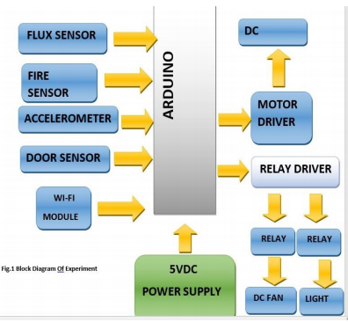

**Specification of Components**

**1.Arduino UNO Board**

The Arduino expansion was emerged in ITALY to build up low cost hardware for communicating design. This Arduino UNO s an excellent choice for any IOT applications design and, one can expect and carve programs according to the

needs. The Arduino UNO board acts as a control unit in this experiment.

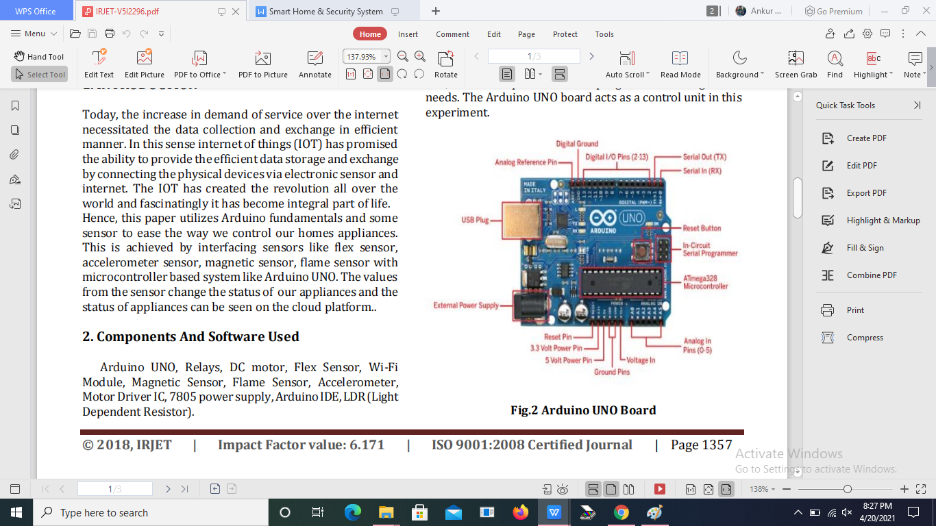

**Some Technical Specification of Arduino Uno is:**

1. Micro controller ATmega328P
2. Operating Voltage 5V
3. Input Voltage (recommended) 7-12V
4. Input Voltage (limits) 6-20V
5. Digital O Pins 14
6. Analog Input Pins 6
7. DC Current per O Pin 40 Ma
8. DC Current for 3.3V Pin 50 mA
9. Flash Memory 32 KB of which 0.5 KB used by boot loader
10. SRAM 2 KB
11. EEPROM 1 KB
12. Clock Speed 16 MHz

**Pin Description**

|  |  |  |
| --- | --- | --- |
| Pin Category | Pin Name | Details |
| Power | Vin, 3.3V, 5V, GND | Vin: Input voltage to Arduino when using an external power source.  5V: Regulated power supply used to power micro controller and other components on the board 3.3V: 3,3V supply generated by on-board voltage regulator. Maximum current draw is 50nA. GND: ground pins. |

|  |  |  |
| --- | --- | --- |
| Reset | Reset | Resets the micro controller, |

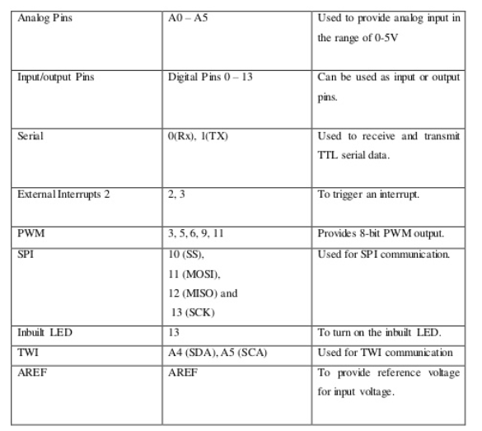

1. **5V Relays**

A relay is an electrically operated switch. Many relays use an electromagnet to mechanically operate a switch, but other operating principles are also used, such as solid-state relays. Relays are used where it is necessary to control a circuit by a

separate low-power signal, or where several circuits must be controlled by one signal.

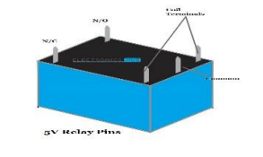

**4-Channel relay module**

This is a SV 4-channel relay interface board, and each channel needs a 15-20ma driver current. It can be used to control various appliances and equipment with hrge current. It is equipped with high-current relays that work under AC250V 10A or DC3OV 10A. It has a standard interface that can be controlled directly by micro controller 3.4.1 Principle From the picture below, you can see that when the signal port is at low level the signal light will light up and the opto coupler 7817e (it transforms electrical signal by light and can isolate input and output electrical signal) will conduct, and then the transistor will conduct, the relay coil will be electrified, and the normally open contact of the relay will be closed.

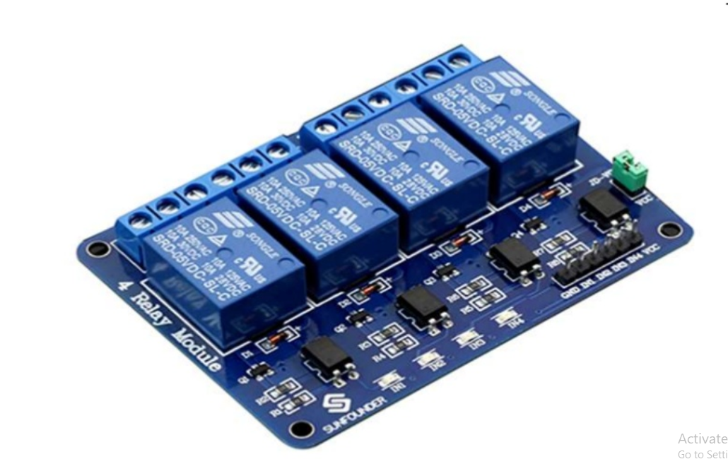

When the signal port is at high level, the normally closed contact of the relay will be closed. So you can connect and disconnect the bad by controlling the level of the control signal port.

**3. DC Motor**

Geared DC motors can be defined as an extension of DC motor. A geared DC motor has a gear assembly attached to the motor.

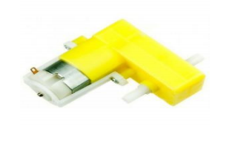

A **DC motor** (**Direct Current motor**) is the most common type of **motor**. ... If you connect these two leads directly to a battery, the **motor** will rotate. If you switch the leads, the **motor** will rotate in the opposite direction. Warning − Do not drive the **motor** directly from **Arduino** board pins. This may damage the board.

**4.FLEX SENSOR**

A flex sensor or bend sensor is a sensor that measures the amount of deflection or bending. This flex sensor is a variable resistor like no other. The resistance of the flex sensor increases as the body of the component bends. This sensor is

used in our experiment to control the lightening of our house to turn it ON or off.

**APPLICATION**

• Human Machine Interface devices

• Security system

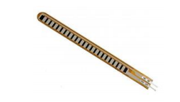

1. **WI-FI Module**

Micro-controller access to your WiFi network. The ESP8266 is capable of either hosting an application or offloading all Wi-Fi networking functions from another application processor.

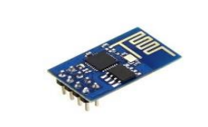

### **ESP8266-01 Features**

* Low cost, compact and powerful Wi-Fi Module
* Power Supply: +3.3V only
* Current Consumption: 100mA
* I/O Voltage:  3.6V (max)
* I/O source current: 12mA (max)
* Built-in low power 32-bit MCU @ 80MHz
* 512kB Flash Memory
* Can be used as Station or Access Point or both combined
* Supports Deep sleep (<10uA)
* Supports serial communication hence compatible with many development
* platform like Arduino
* Can be programmed using Arduino IDE or AT-commands or Lua Script

**6.FLAME SENSOR**

A flame sensor "senses" a weak DC signal from the AC power sent to the ignitor which via the phenomenon of flame rectification in which the polarity of power sent through a flame is rectified to DC. This sensor is used in our experiment to detect the fire in the house and then send an alert through buzzer.

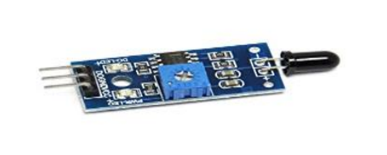

A sensor which is most sensitive to a normal light is known as a flame sensor. ... This sensor detects flame otherwise wavelength within the range of 760 nm – 1100 nm from the light source. This sensor can be easily damaged to high temperature. So this sensor can be placed at a certain distance from the flame.

**7.ACCLEROMETER**

Accelero meters are devices that measure acceleration, which is the rate of change of the velocity of an object. They measure in meters per second squared (m/s2) or in G-forces (g). The values are represented in X, Y and Z coordinates. These values are used to control the rotation of motor.

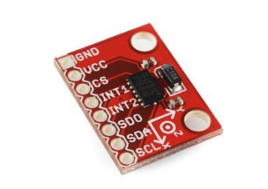

An accelerometer is a tool that measures proper acceleration. Proper acceleration is the acceleration of a body in its own instantaneous rest frame; this is different from coordinate acceleration, which is acceleration in a fixed coordinate system.

Accelerometers have many uses in industry and science. Highly sensitive accelerometers are used in [inertial navigation systems](https://en.wikipedia.org/wiki/Inertial_navigation_system" \o "Inertial navigation system) for aircraft and missiles. Vibration in rotating machines is monitored by accelerometers. They are used in [tablet computers](https://en.wikipedia.org/wiki/Tablet_computer" \o "Tablet computer) and digital cameras so that images on screens are always displayed upright. In [unmanned aerial vehicles](https://en.wikipedia.org/wiki/Unmanned_aerial_vehicles" \o "Unmanned aerial vehicles), accelerometers help to stabilise flight.

**8. LDR (LIGHT DEPENDENT RESISTOR)**

Light dependent resistors, LDRs or photo resistors are often used in circuits where it is necessary to detect the presence or the level of light. In this experiment we have used LDR to have automatic light control such that when there is brightness light is automatically OFF else it is ON.

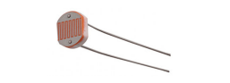

### ****LDR Pin Description****

The ****Light Dependent Resistor**** (****LDR****) is just another special type of Resistor and hence has no polarity. Meaning they can be connected in any direction. They are breadboard friendly and can be easily used on a perf board also. The symbol for LDR is just as similar to Resistor but adds to inward arrows as shown above. The arrows indicate the light signals.

### ****LDR Features****

* Can be used to sense Light
* Easy to use on Breadboard or Perf Board
* Easy to use with Microcontrollers or even with normal Digital/Analog IC
* Small, cheap and easily available
* Available in PG5 ,PG5-MP, PG12, PG12-MP, PG20 and PG20-MP series

### ****Applications of LDR****

* Automatic Street Light
* Detect Day or Night
* Automatic Head Light Dimmer
* Position sensor
* Used along with LED as obstacle detector
* Automatic bedroom Lights
* Automatic Rear view mirror

**9.MQ-2 Smoke**

The MQ-2 Smoke LPG Butane Hydrogen Gas Sensor Detector Module is useful for gas leakage detection (home and industry). It is suitable for detecting H2, LPG, CH4, CO, Alcohol, Smoke or Propane. Due to its high sensitivity and fast response time, measurement can be taken as soon as possible. The sensitivity of the sensor can be adjusted by the potentiometer.

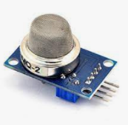

MQ-2 gas sensor using gas sensitive material is to be clean air in the lower conductivity of Tin oxide (SnO2). When the sensor when flammable gases are present in the environment in which the conductivity of the sensor with an increasing concentration of combustible gas in the air increases.

Use a simple circuit to convert the changes in conductivity and output signal that corresponds to the concentration of the gas.

MQ-2 gas sensor higher sensitivity to liquefied petroleum gas, propane, hydrogen, detection of gas and other combustible vapors are ideal. This sensor can detect a variety of flammable gas, is a low-cost sensor for many applications.

**10.PIR sensor**

A passive infrared sensor (PIR sensor) is an electronic [sensor](https://en.wikipedia.org/wiki/Sensor" \o "Sensor) that measures [infrared](https://en.wikipedia.org/wiki/Infrared" \o "Infrared) (IR) light radiating from objects in its field of view. They are most often used in PIR-based [motion detectors](https://en.wikipedia.org/wiki/Motion_detector" \o "Motion detector). PIR sensors are commonly used in security alarms and automatic lighting applications.

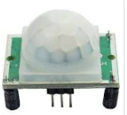

PIR sensors detect general movement, but do not give information on who or what moved. For that purpose, an [imaging IR sensor](https://en.wikipedia.org/wiki/Thermographic_camera" \o "Thermographic camera) is required.

PIR sensors are commonly called simply "PIR", or sometimes "PID", for "passive infrared detector". The term *passive* refers to the fact that PIR devices do not radiate energy for detection purposes. They work entirely by detecting [infrared radiation](https://en.wikipedia.org/wiki/Infrared_radiation" \o "Infrared radiation) (radiant heat) emitted by or reflected from objects.

1. **Buzzer**

A **buzzer** or beeper is an audio signalling device, which may be mechanical, electromechanical, or piezoelectric (piezo for short). Typical uses of **buzzers** and beepers include alarm devices, timers, and confirmation of user input such as a mouse click or keystroke.

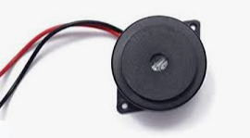

**PROJECT WORKING**

This Project basically consists of three Major and important parts i.e. sensing, monitoring, and controlling system. The first part sensing is done by sensors like flex sensor, accelerometer etc. the monitoring task is done by the cloud platform and the controlling part is done by our micro-controller unit i.e. is Arduino UNO.

The sensors, appliances and Wi-Fi module are interfaced with Arduino UNO. The value of sensors brings a change in the status of our appliances. The flex sensor depends on the gestures of our fingers to control the appliances. The accelerometer controls the opening and closing of door. The magnetic sensor alerts us if the door lock breaks. The flame sensor alerts us if there is fire in the house. The status of our

appliances are uploaded on the cloud platform and the user can see the status on his laptop and smartphone as well. The Arduino UNO controls the appliances on the basis of value given by sensors.

1. **Pros of Smart Home And Security System**
2. **Security**

Tap your finger to tum on the lights when you get home so you worried about what's hiding in the shadows, or in your pathways. Or automate to tum on when you aren't home to look like you are to ward off potential robbers. Door bells are another automated home product that can increase your home security.

1. **Energy Efficiency**

Increase your home's energy efficiency by remotely powering off systems and appliances when they aren't in use. In addition to the standard home automation products that give you active control, some products actively monitor systems and am the homeowner with knowledge, insight and guidance to achieve greater control and energy efficiency,

1. **Savings**

Home automation literally pays off. When you are able to use home systems and appliances only when needed, the savings will be apparent in the first utility bill No more wasting money on lights left on when you aren't home, or spending money on gas to drive home because you forgot to lock the door. Monetary savings apparent, you'll also be saving time. No wasted trips home, no running through the house turning everything off no time spent worrying about what was or wasn't turned off

1. **Convenience**

Don't you hate having to rely on neighbors to watch you house when you're gone? With home automation convenient control of your home is at your fingertips. You don't have to trust someone eke with your most valued possessions.

**Applications Of This Project**

1. Using this project, we can turn on or off appliances remotely i.e. using a phone or tablet.
2. The project can be further expanded to a smart home automation system by including some sensors like light sensors, temperature sensors, safety sensors etc. and automatically adjust different parameters like room lighting air conditioning (room temperature), door locks etc. and transmit the information to our phone
3. Additionally. we can connect to internet and control the home from remote location over internet and also monitor the safety. Future Development of the project.
4. Arduino based device control using wifi on Smart-phone project can be enhanced to control the speed of the fan or volume of the buzzer etc.
5. Home automation and Device controlling can be done using Internet of Things - IOT technology.

**Conclusion**

The IOT facilitates numerous benefits to the society and from our Project we can provide and prove the strength of IOT that is capable to contribute the services for the purpose of building vast no. of applications and help to implement them on the public platform. This design provides moderate and less expensive way of sensing, monitoring and controlling system in the field of domestic and as well as industrial

standard to implement IOT. At a final note, we conclude that IOT leads to become

universal in every aspect. This project will be very beneficial in our normal day to day life and will bring much needed innovation in his fast changing world of technology where people prefer to have control over things using the smartphones which will bring ease to their routine life.